- \Operation\Carton erection\Carton feeding
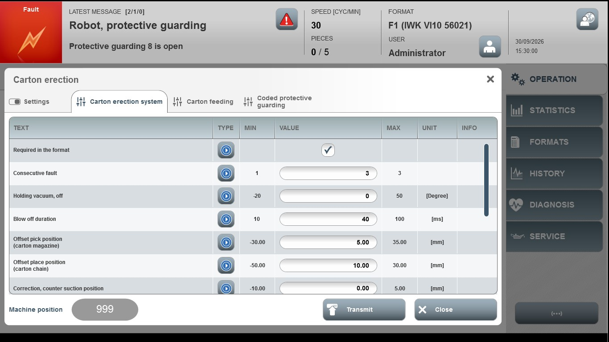
Acceptance criterion | Limits | Pass / Fail: Dev-No. | Date | Initials
Screen matches screenshot | N / A
Feed time | 50…1000
Break duration | 50…1000
Speed | 5…100
Vibrator interval | 1…10
Vibrator duration | 1.00…5.00

